Stanley Furniture- $330.00

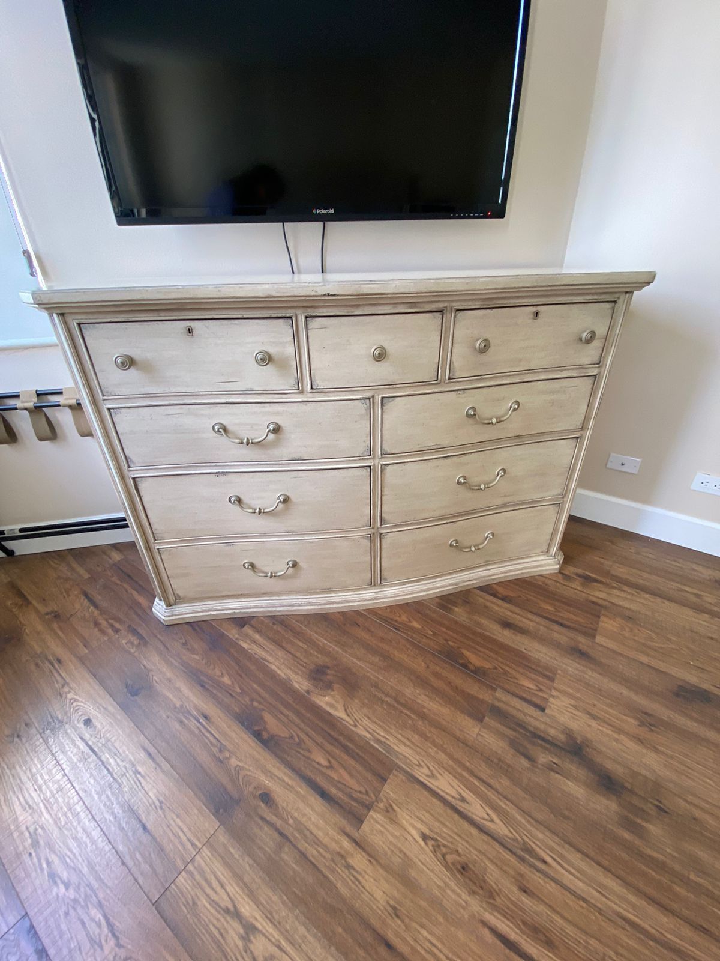

King Bed Frame for $740.00. Made in Indonesia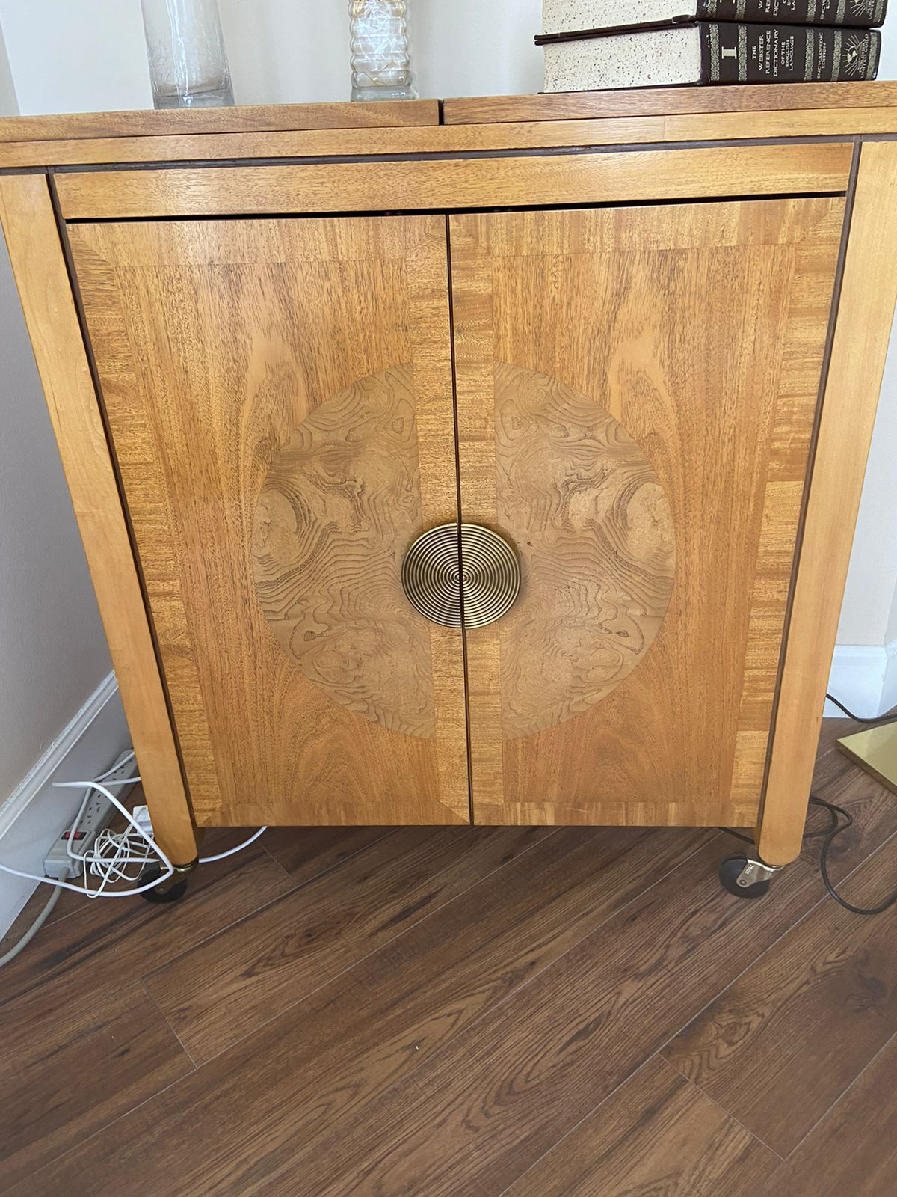Made in Indonesia, Bloomingdales $500.00Made in Indonesia, Bloomingdales $150.00El Dorado $95.00 with stools

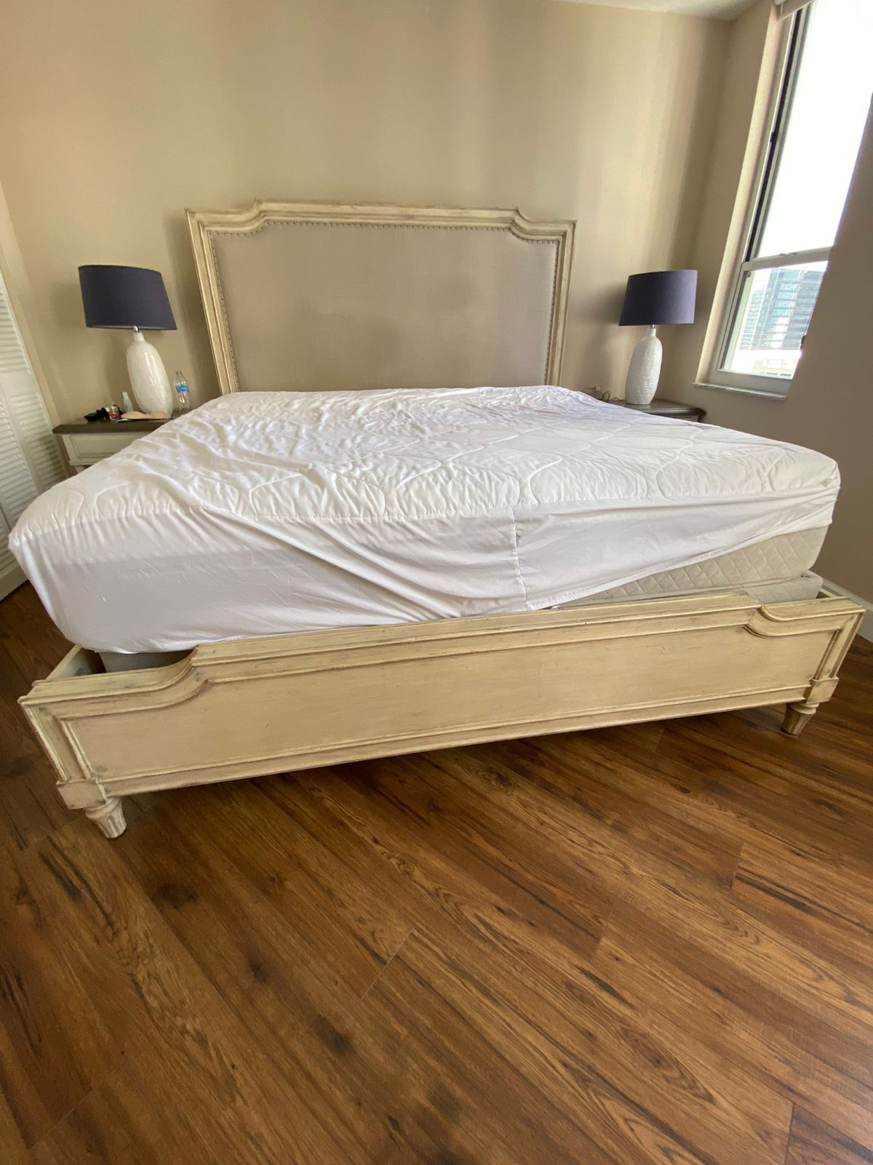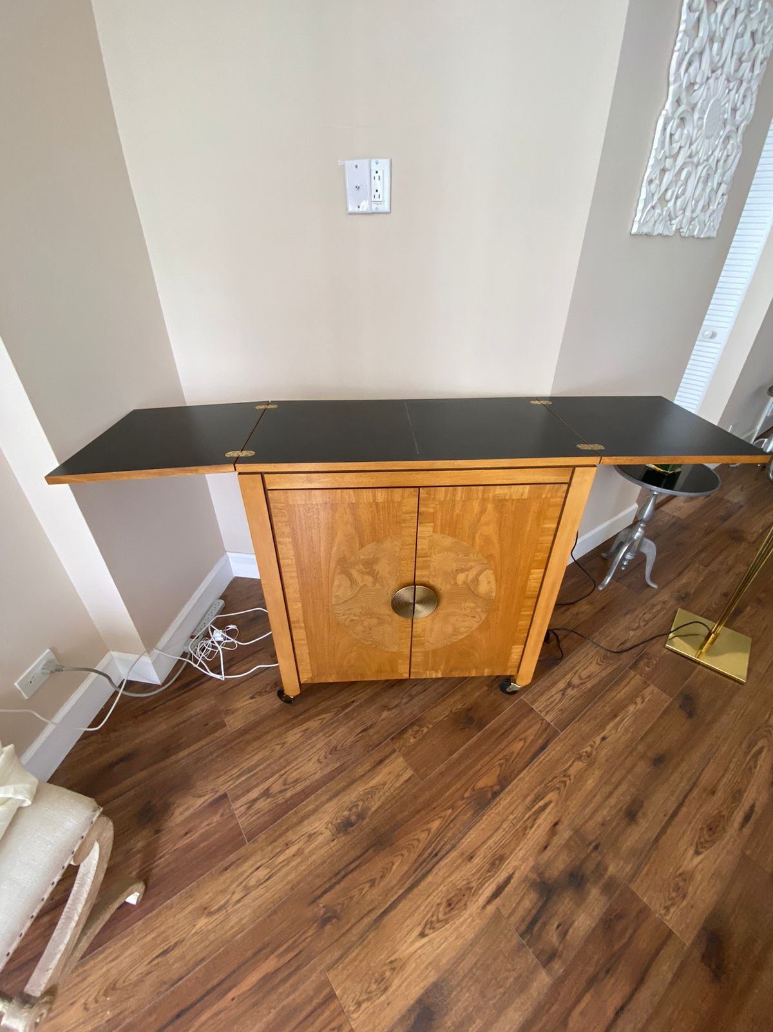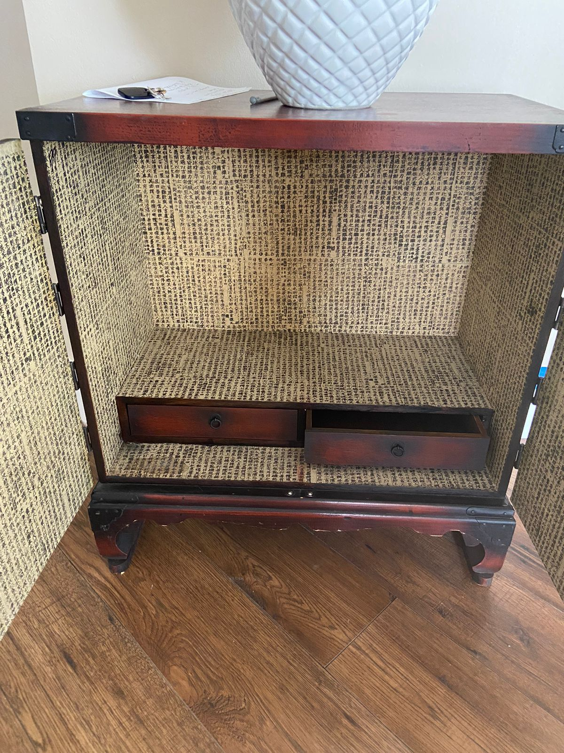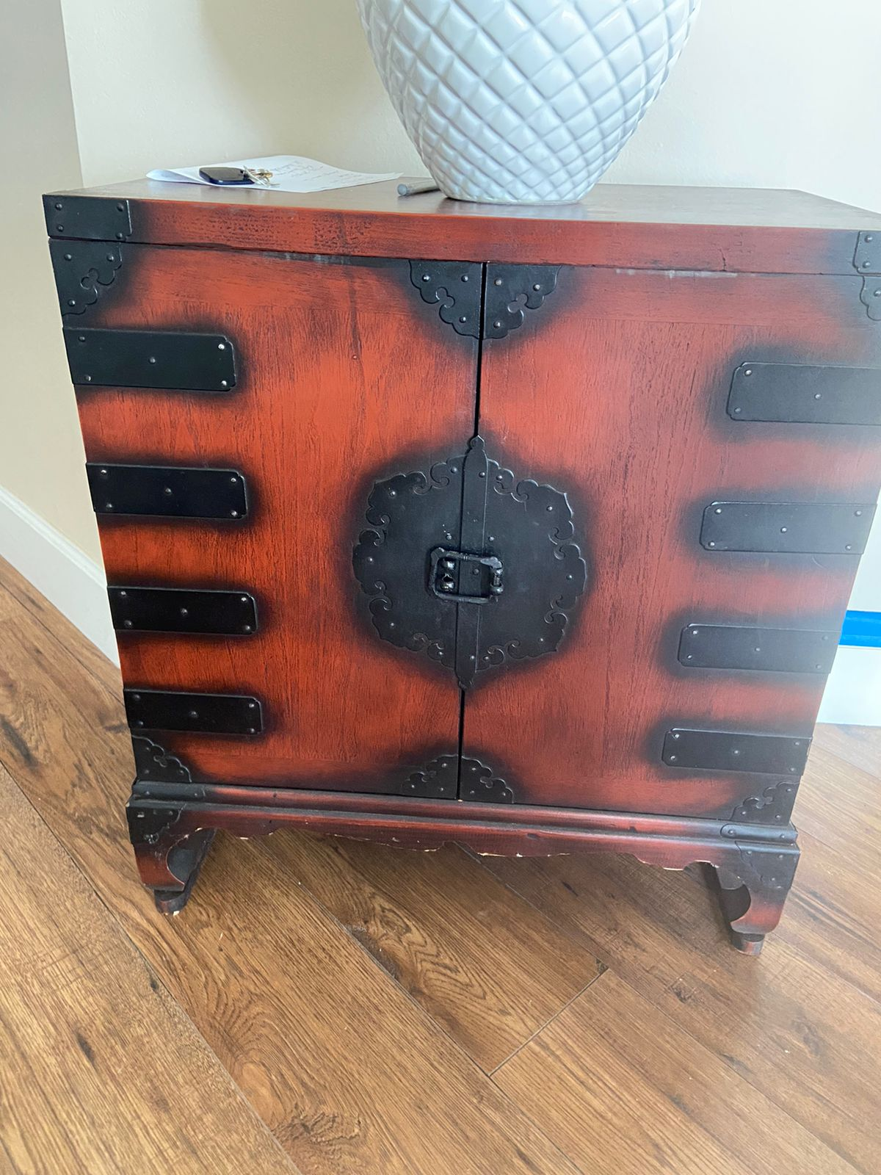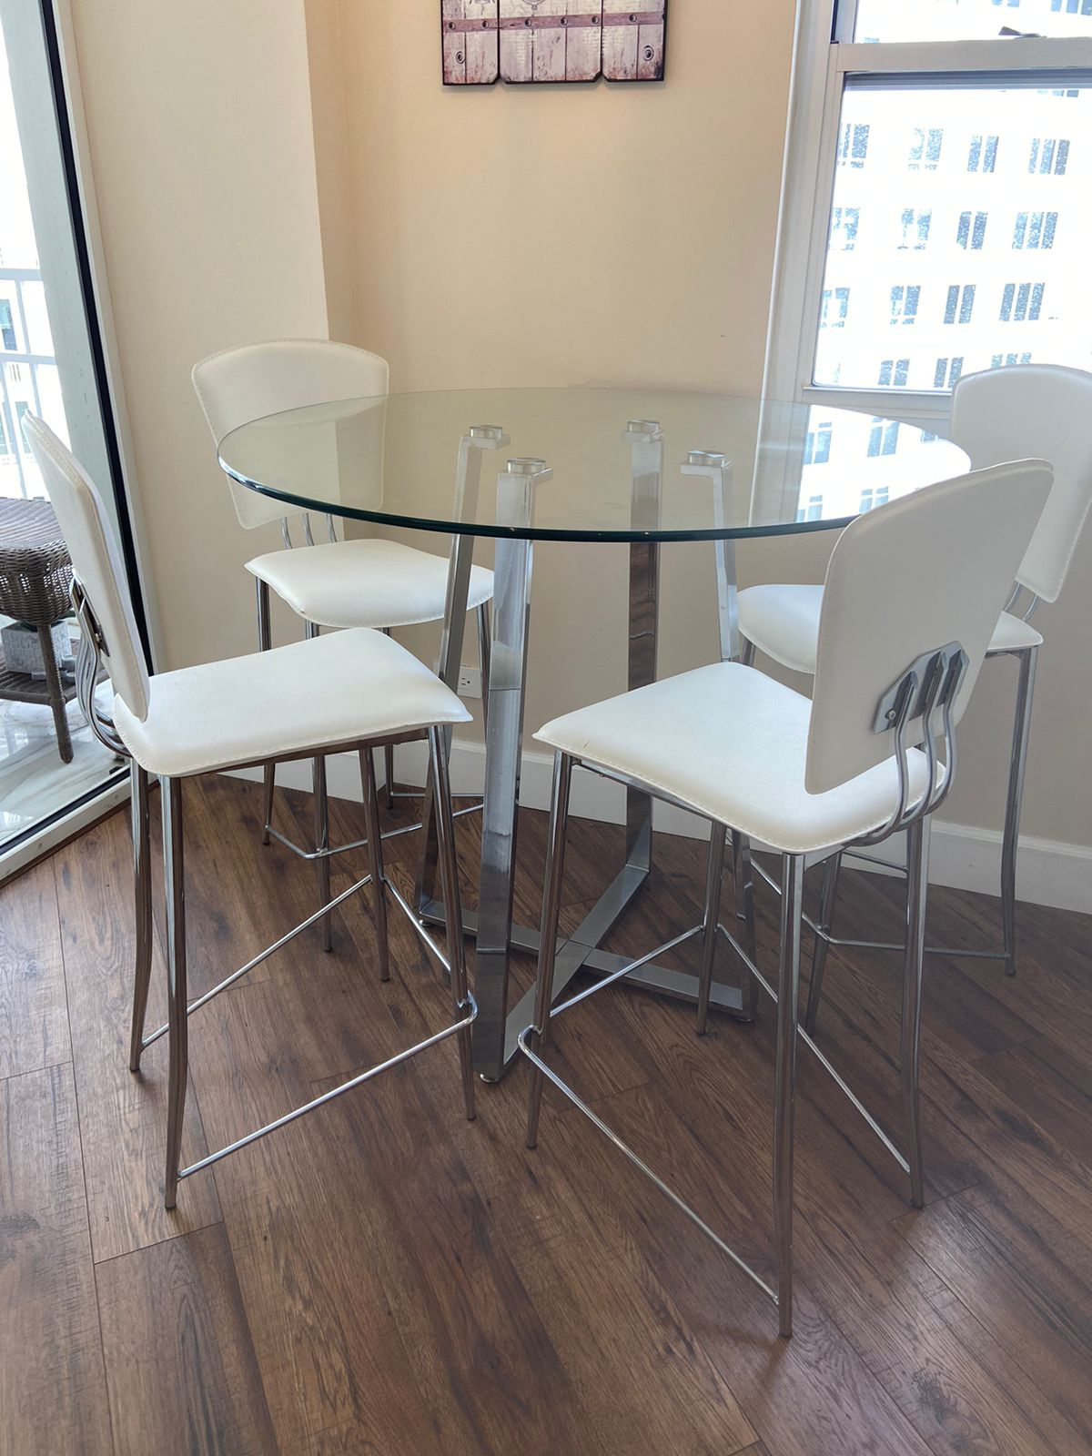

Victoria’s Armoire- Top made from Valcanic Rock- $240.00

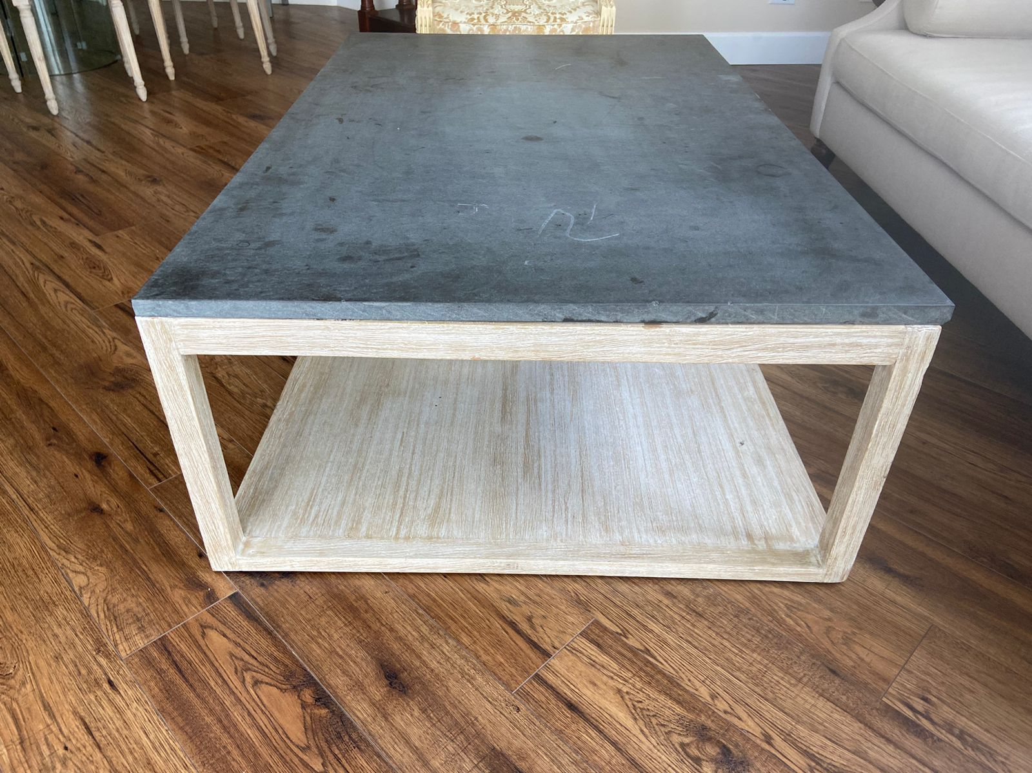

Victoria’s Armoire- $360.00Bloomingdales Bamboo Ratan- $185.00Bloomingdale Bamboo- $180.00

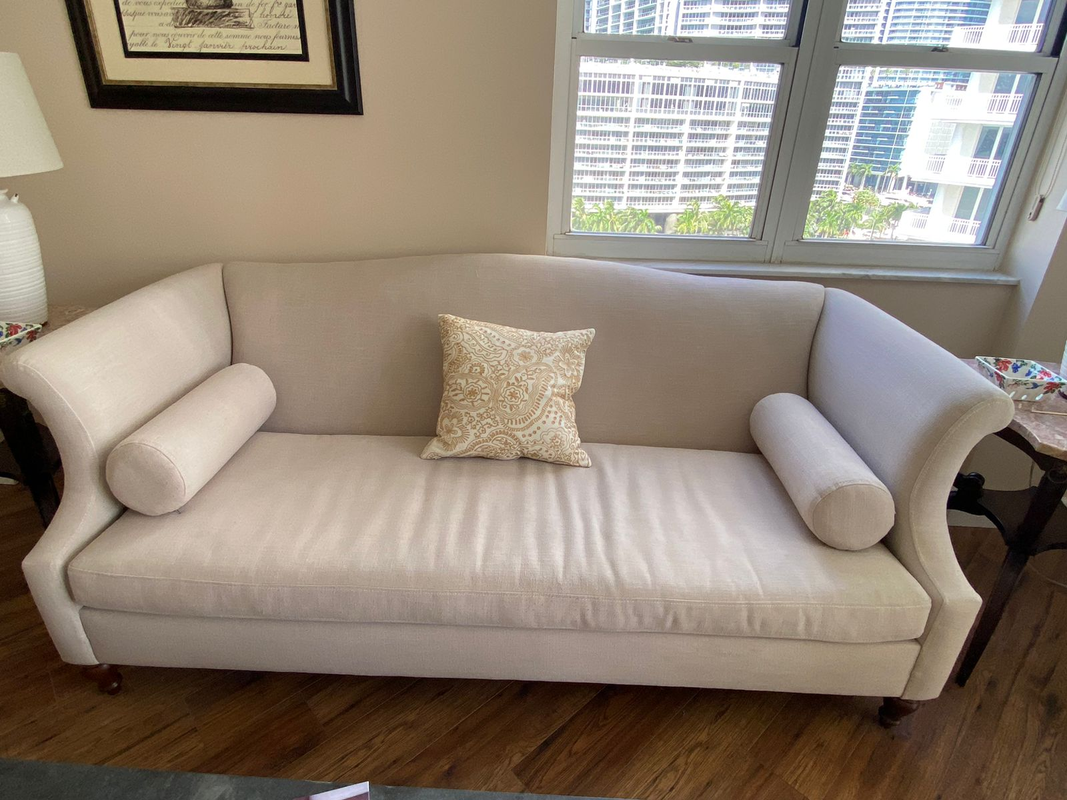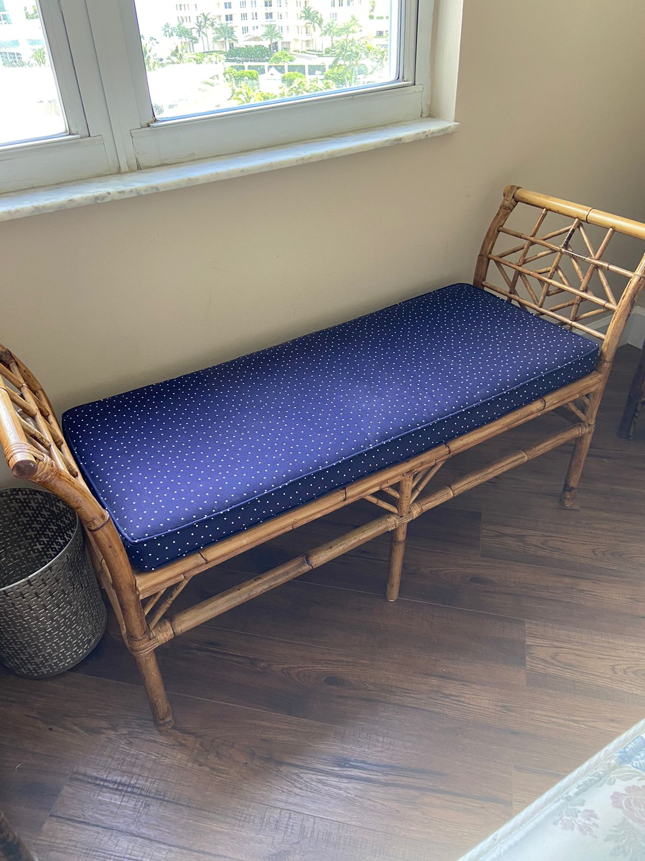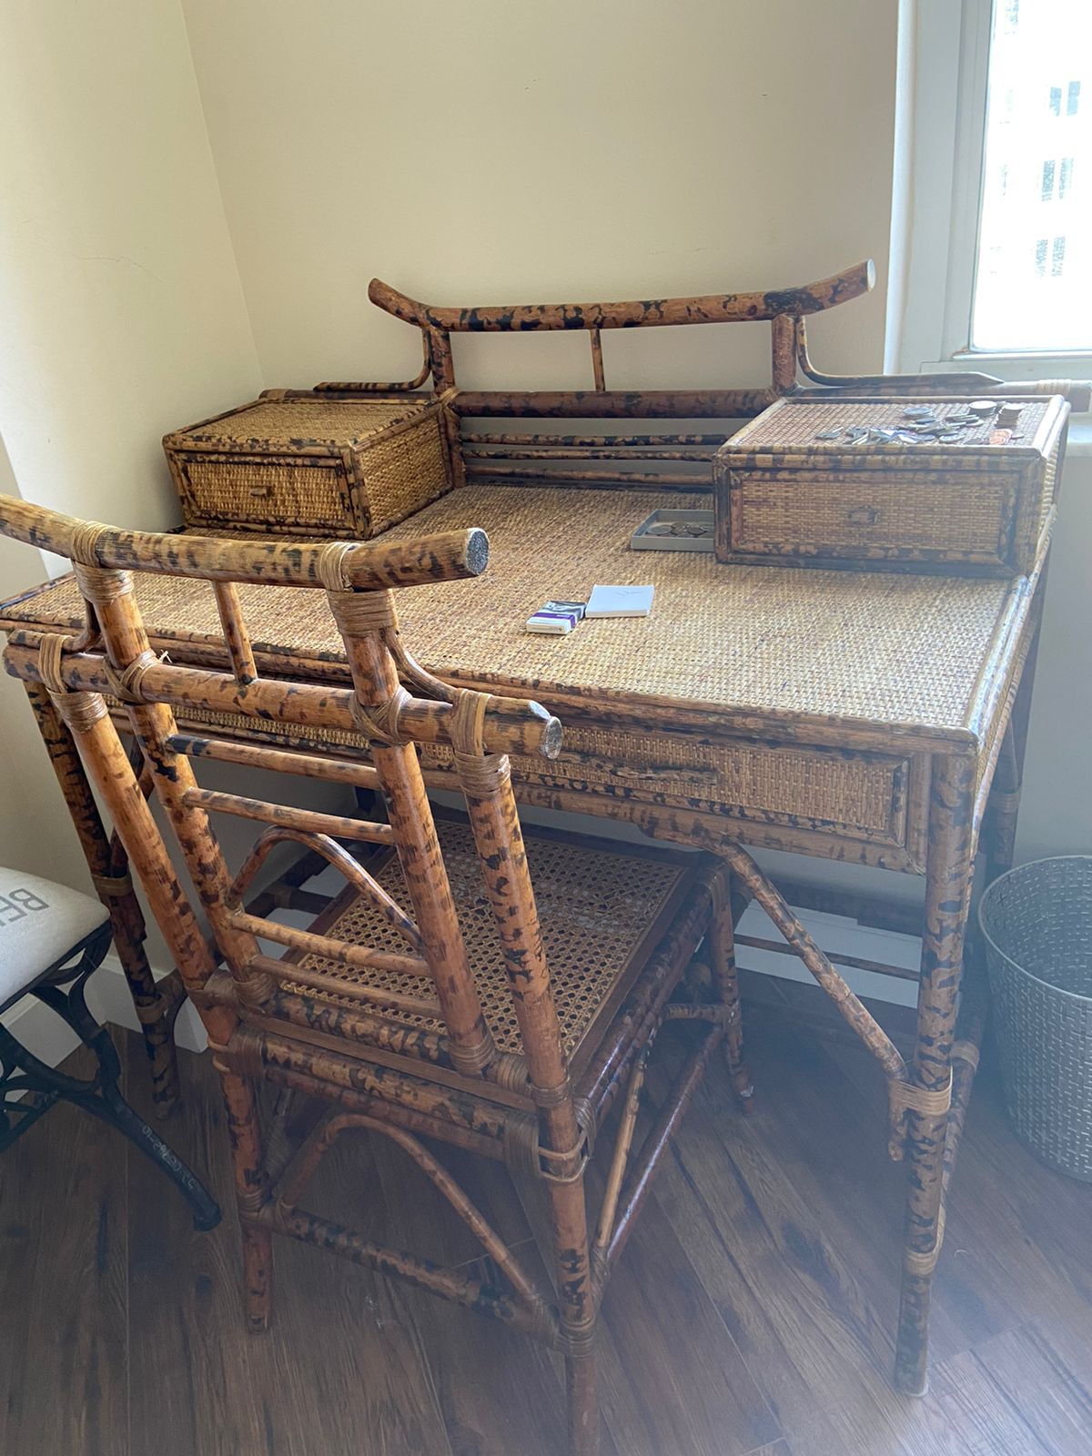

Bloomindale’s Bamboo Ratan- $230.00Bloomingdale’s Night Stand- $99 each.

